OE Summer 2018 Quiz Answers

- BRM V-16, 1.5 liters, 2 stage supercharger and crankcase. Developed 600hp at 12000 rpm, with 80 psi boost in 1950!
Engine sound: https://www.youtube.com/watch?v=fZMPDCNyQxE
Engine installed in race car: https://www.flickr.com/photos/44381054@N05/6050476200
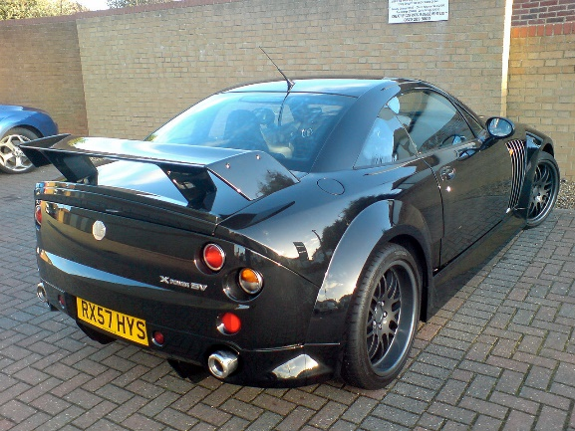
- The MG XPower SV is a sports car that was produced by MG Rover. Manufactured in Modena, Italy and finished at Longbridge, United Kingdom, it was based on the platform of the Qvale Mangusta, formerly the De Tomaso Biguà.
- 2 Liter VTEC – 16, 4 intake and 12 exhaust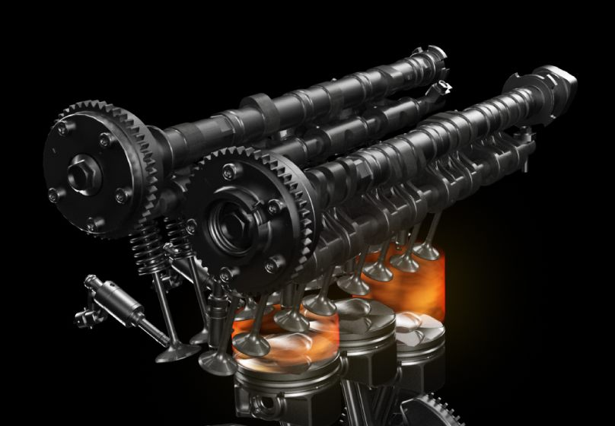
- What was the support race at the Inaugural Formula 1 race in 1950, who were the 1st and 2nd finishers?
At the inaugural world championship Grand Prix in his homeland the then 20-year-old Stirling Moss only appeared in the 500cc support races, not in the main event. Moss won his heat and was involved in a barnstorming battle for the lead in the final, but in the end had to settle for second place after his Cooper-JAP suffered a piston failure at the final corner. Stirling upgraded his car again for 1950, now to a Cooper Mk IV but the Royal Silverstone race proved frustrating with over 100,000 spectators watching. He won his heat but holed a piston in the final and had to coast the car over the line for second to the Iota of Frank Aikens with new boy Peter Collins a mere 0.4 of a second behind!
- Diesel fuel has a higher energy density than gasoline. On average, 1 gallon (3.8 L) of diesel fuel contains approximately 155x10⁶ joules (147,000 BTU), while 1 gallon of gasoline contains 132x10⁶ joules (125,000 BTU). This, combined with the improved efficiency of diesel engines, due to higher compression ratio, explains why diesel engines get better mileage than equivalent gasoline engines.
- Unsportsmanlike conduct – FOIA sanctioned races.
- Ford Cortina GT year?: Trick question. 1964 with 1965 front end.
- Which female driver recorded the fastest lap of a race in 2011? Which race?
Simona de Silvestro received criticism from broadcasters during the race as she raced hard against the leaders even when she was several laps down, rather than letting them pass. She started 13th and finished 20th, nine laps down, but recorded the fastest lap of the São Paulo Indy 300,
- Which Autocross class allows modified lever shocks?
Heritage Classic Street (HCS). Lever shock absorbers may be modified. They may be replaced with tube shocks unless they also serve as suspension component such as a control arm (Example; front shocks on an MGB).
- Autocross: An efficient and highly addictive legal function used for (1) drastically reducing the tread life of a set of tires, (2) mercilessly destroying orange cones and (3) ruining a vehicle's alignment.
- Solo:
  - a thing done by one person unaccompanied.
  - a person who performs or accomplishes something without the usual equipment
  - Solo drivers are required to stop and take time off to sleep before they can resume work.
  - What you do after you pass your learner test.
- Race : any time you see another horse, boat, car, bicycle etc, and you belong to SCCA, then it’s a race.
- Which 1940’s car is permanently exhibited in the New York Museum of Modern Art?
Cisitalia 202 GT 1946 

